
MARKETING/MANAGEMENT DEPARTMENT
MKT 350 – Principles of Marketing
FIN: Final Exam
by Markus Biegel

INTRODUCTION:
- Your final exam has three parts. They are easy! I purposely made this final easy. Yet for Part 1 I still need to see solid effort. For Part 1 these are not short answers, they should be comprehensive.
- The final exam is due May 14th at midnight.
- If you turn in your final exam late (for whichever reason) your final exam grade points will be cut in half (50% of your actual score). So please don’t turn in your final late as it is heavily penalized on points.

PART 1: ESSAYS - 90 Points (30 Points Each)

Essay 1 - SWOT: (30 Points)
Compare two companies/brands from the same industry using S.W.O.T. methodology. You must choose from one of the following industries:
Electronics Industry OR Restaurant Industry
Essay 2 – 4Ps: (30 Points)
Compare two companies/brands from the same industry using the marketing mix (4Ps) model. You must choose from one of the following industries:
Apparel/Fashion Industry OR Airline Industry
Essay 3 – Small vs. Big: (30 Points)
When comparing large Fortune 500 companies to small businesses (less than 500 employees) how does the role of marketing change and how is it the same? How is marketing’s contribution to the business planning process in these two environments same and/or different? How are the marketing metrics that are being measured the same or different? You may answer this question on the macro-level or choose a specific industry to compare and contrast a large and small firm (or you can do both, macro first and them exemplify with two specific companies).

PART 2: ETHICS ASSESSMENT – Multiple Choice Questions (5 Points)

Questions 1-5 are T/F/MC Questions

- The legal environment sets the minimum standards of ethical behavior in a society.
True False

- According to a survey of workers, almost half of them have admitted to taking some type of unethical or illegal action in the recent past.
True False

- The future poses many challenges for marketing managers because:
A. new technologies are making it easier to abuse consumers' rights to privacy.
B. the marketing concept has become obsolete.
C. it is marketing managers who have full responsibility to preserve our macro-marketing system.
D. social responsibility applies only to firms--not to consumers.
E. ultimately it is marketing managers who must determine which products are in the best interests of consumers.

- Which of the following statements about ethical behavior in business is true?
A. The legal environment sets the highest standards of ethical behavior.
B. The legal environment sets the maximum standards of ethical behavior.
C. The legal environment sets the minimum standards of ethical behavior.
D. The legal environment sets the normative standards of ethical behavior.
E. None of the above.

- Which of the following is an unethical behavior on the part of a consumer?
A. abusing policies about returning goods.
B. changing price tags in self-service stores.
C. being abusive to salespeople.
D. shoplifting.
E. all of the above.

PART 3: ETHICS ASSESSMENT – Case Study (5 Points)

Please read the case and answer the last two questions in the last paragraph.
Case American Apparel: unwrapping ethics. (This case is cited from Harvard Business Education, by June Cotte; Seung Hwan (Mark) Lee; Brittany Schuette)
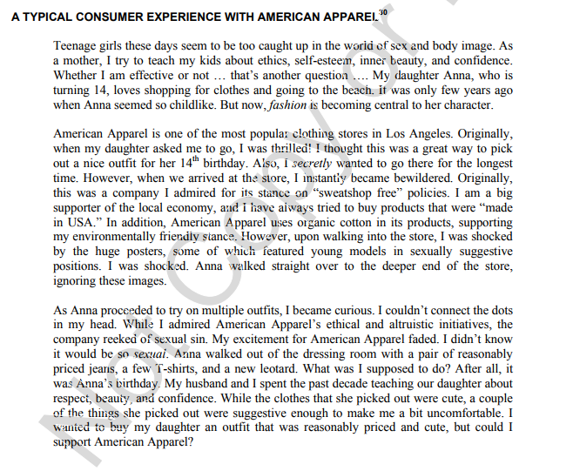
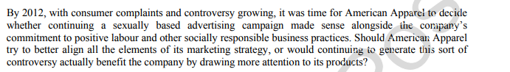
(Cited from Harvard Business Education, by June Cotte; Seung Hwan (Mark) Lee; Brittany Schuette).

